****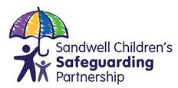

**7 KEY MESSAGES – To understand and apply Sandwell’s ‘refreshed’ Multi-Agency Request Form (MARF) November 2022**

**02 Consent-based Request for Statutory Social Care intervention:**

Working ‘with’ families means being open, honest and inclusive.

It is your responsibility to speak to parents/carers about your concerns.

As of 1st December 2022, Sandwell Children’s Trust will only accept requests for service if:

1. Parental consent has been obtained,
2. In exceptional circumstances when

‘consent cannot be obtained, it cannot be reasonably expected that a practitioner obtains consent or if to gain consent

would place a child at risk, undermine the prevention, detection or

prosecution of a serious crime.

**01 Sandwell’s Multi Agency Request Form**

On 1st December 2022, Sandwell’s refreshed MARF will come in to effect. The MARF follows a lengthy consultation process from across all multi agency partners.

The MARF is a form to request services from Sandwell Children’s Trust (SCT) for statutory Children’s Social Care services/support.

**03 – A Shared approach and understanding to apply the Sandwell MARF**

The MARF relies on professionals providing clear written evidence to support their request for services and aims to assist robust and timely decision-making by all professionals. It is important to refer to the Multi Agency Thresholds Guidance: ‘Continuum of Help & Support’ including: section 3: which details the levels of need and Sandwell’s Windscreen model to aid practitioners to identify when a child may need additional support, and the level of need for a child, young person and their family.

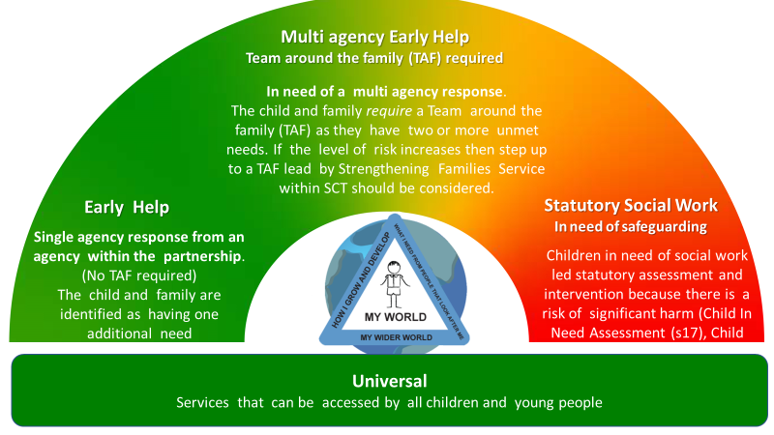

Our strengthened model will support children and families to have access to appropriate, proportionate and timely level of support according to their changing circumstances. This model will ensure families are not subjected to unnecessary and/or intrusive intervention but receive a graduated offer and response from universal, early help, multi-agency early help and statutory social work.

**06- Right Support, Right Place, Right time**

The Children Acts 1989 and 2004 makes clear that the welfare of children is paramount and that they are best looked after within their families, with their parents playing a full part in their lives, unless compulsory intervention in family life is necessary.

The Acts emphasize the need for all practitioners to understand their role in identifying potential and unmet needs of children and families and provide **early help** as soon as a problem emerges.

Request for statutory children social care intervention via a MARF should be the last resort when there is evidence that support already provided by agencies across the continuum has had no impact/concerns are escalating which is/likely to result in long-term/significant harm.

**Click here to download:**

**-Working together to safeguard children, 2018):** [**https://www.gov.uk/government/publications/working-together-to-safeguard-children--2**](https://www.gov.uk/government/publications/working-together-to-safeguard-children--2)

**-Sandwell’s** **‘**[***Multi Agency Thresholds Guidance: Continuum of Help & support***](https://www.sandwellcsp.org.uk/wp-content/uploads/2022/06/Threshold-Guidance-Continuum-of-Help-Support-June-22-002.pdf)**‘ document**

**-Definition of abuse and neglect:** <https://westmidlands.procedures.org.uk/ykpzl/statutory-child-protection-procedures/additional-guidance/#s531>

**05 –**

**Strengths-based Approach**

When it is appropriate to make a request for statutory social work support, it is important to consider the holistic needs of the family in terms of child development, parenting capacity, family and environmental factors.

Be clear about the family’s strengths, what’s working well for this family and how can these be built on.

Parents should haveinsights into different perspectives and understand what is expected of them

***When working with families, focus on strengths and not just problems!***

**07 – Working Together with Children & Families**

In Sandwell, safeguarding children is a joint responsibility of all agencies. The refreshed MARF, designed by all agencies, supports this principle and is therefore NOT a referral form that allows practitioners to ‘hand over’ their concerns and responsibility for Safeguarding to another agency,

instead it is a request for statutory social care services to work in collaboration with multi agency partners to ensure the safety and wellbeing of children and families across the borough.

We have therefore updated the language used in the MARF (from referral to request) to reflect this process.



**2**

**1**

**3**

**4**

**5**

**6**

**7**



**Sandwell’s**

**Refreshed Multi Agency Request Form (MARF)**

**04 – Evidence-based Requests**

It is important for practitioners to evidence theconcerns and how the situation meets the threshold for statutory social work intervention, including:

a. What specifically are your concerns b. what is your evidence

c. Why do you think there is risk of

significant harm

d. What is your evidence

e. What has already been tried

f. what impact has this had,

Include any assessments used to engage and work with a family, i.e.

* Early Help Assessment
* Graded Care Profile 2
* Child Exploitation Tool
* Childs Voice
* Outcome Star
* Health Assessment
* Body Map
* Chronology
* Observation record