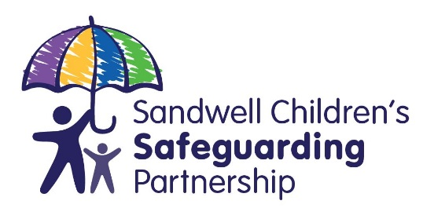

Referral for a Child Safeguarding Practice Review

Criteria for Child Safeguarding Practice Reviews
Serious child safeguarding cases are those in which:
- abuse or neglect of a child is known or suspected and
- the child has died or been seriously harmed
Serious harm includes (but is not limited to) serious and/or long-term impairment of a child’s mental health or intellectual, emotional, social or behavioural development. It should also cover impairment of physical health. Any individual or organisation working with children should inform the relevant safeguarding partners of any incident they think should be considered for a child safeguarding practice review, or other type of learning review, using this form.

Professionals should discuss the case with their agency designated safeguarding lead/officer to help formulate the rationale. If you need advice completing this form please contact us: our phone and email address are included at the end of this form. A referral should be made as soon as possible after the serious incident occurs.

Background Information

Name of Child:

Date of Referral:

Agency Referral

Name | AGENCY & DESIGNATION/TITLE | CONTACT DETAILS – Address, telephone number and e-mail address
Please give the details of the designated safeguarding lead/officer with whom you have discussed the case.

Name | AGENCY & DESIGNATION/TITLE | CONTACT DETAILS – Address, telephone number and e-mail address

Section 1: Brief overview of child and family composition

  - Child’s Details

Name of Child
Date of Birth
Home address
Gender
Ethnic Origin
Faith/Religion
Disability
Is the child/young person looked after?
Is the child/young person subject to a child protection plan or has been previously? (If so when, for what and for how long?)
Is the child/young person open to Children’s Social Care or a Children & Families Practice (if so, who is the lead practitioner)?
Date of Death or Serious Incident (please specific which)
Address of location of incident
Carer at time of incident
Is this case known to be the subject of a criminal investigation? (If so, who is the lead investigator?)
Is this case known to be the subject of a Coroner’s Inquiry? (If so, who is the key contact?)
Are there any adult safeguarding concerns and have these been shared via completing an Adult referral form? (If so, who is the key contact?

1.2 Details of Family Members and any Significant Others
Name and Address | Relationship to Child | Date of Birth | Legal Status | Ethnic Origin

What action has been undertaken to safeguard and protect any siblings of the child who is the subject of this referral?

1.3 Other agencies known to be involved

Agency | Contact Details: Address, Telephone and E-mail | Reason for involvement  (include whether current or not)

Section 2: Case Background

PLEASE NOTE: The information you provide will be used to help establish whether the case meets the criteria for a Child Safeguarding Practice Review or other type of learning review.

Please provide a brief outline of the child and family circumstances and the incident that triggered this referral:

Please outline why you are making this referral:

Please use the chronology table below to outline any events around the time of the incident.

PLEASE NOTE: This should only include key events and DOES NOT need to be a detailed chronology at this stage.

Date and Time | Event

Please add any additional information you think may be relevant and may assist decision-making:

NOTE: THE ABOVE SHOULD FOLLOW A DISCUSSION WITH A NOMINATED MANAGER OR SAFEGUARDING ADVISOR IN YOUR AGENCY.

Section 3: Advice and Submission of this Form
For advice on completing this form please contact Sandwell Children’s Safeguarding Partnership on 0121 569 4800 or via email at SCSP_CSPR@sandwell.gov.uk

Please submit the form to SCSP_CSPR@sandwell.gov.uk

A multi-agency Rapid Review of your referral will be undertaken and you will be informed of the outcome.

Child perpetrators may also be the subject of a review, if the definition of ‘serious child safeguarding case’ is met.
The formal safeguarding partners are the CCG, police and the local authority. Details of where to send this form are included at the end of the form.
Please note that, as the referrer, you may be required to present the referral at the local Child Safeguarding Practice Review Group.

