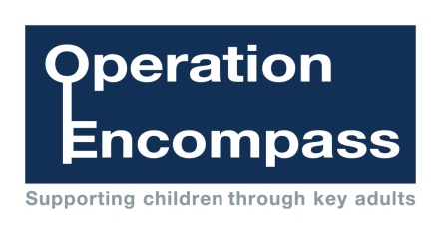

In every force, in every school, for every child

Place your school and local police force logo here

Operation Encompass is the early reporting on to schools that a child or young person has been exposed to domestic abuse